Dear Brother Blaylock:

May I petition for a point I missed on question #7? I had full understanding of the principles when I answered it but over complicated the question. All the screen shots below except for the first I took while I was answering the question. I remembered what *The CSS Master book* stating that pseudo-elements were not compatible as arguments for the :not() pseudo-class. But I also noted when I read the book that it was printed in 2015, so I tried it and it functioned. Therefore, I was perplexed what to do on the test question. Since I didn’t know what browsers it was compatible with and the source given to us to study sited it as not working, I took screen shots at the time showing that it worked, but also sited the text and figured I better play it safe. I feel the work I did to study material shows gave me sufficient understanding, but my interpretation of the factors to answer the question as expected failed.

Question 7:

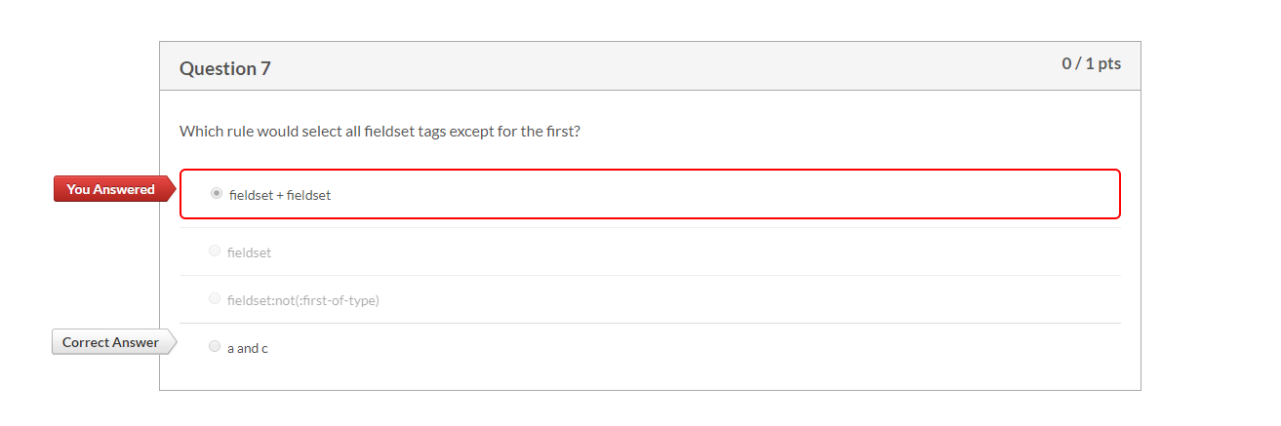

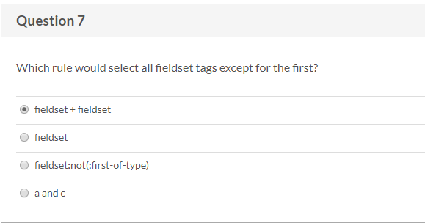

Citation that:first-of-type is an element.

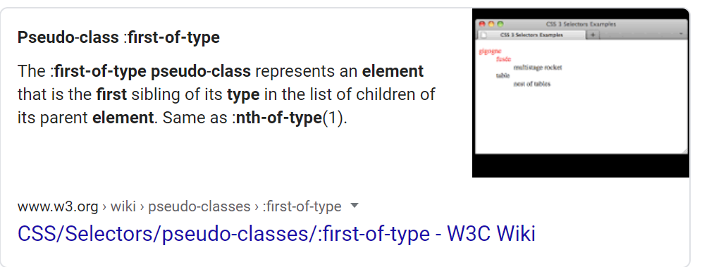

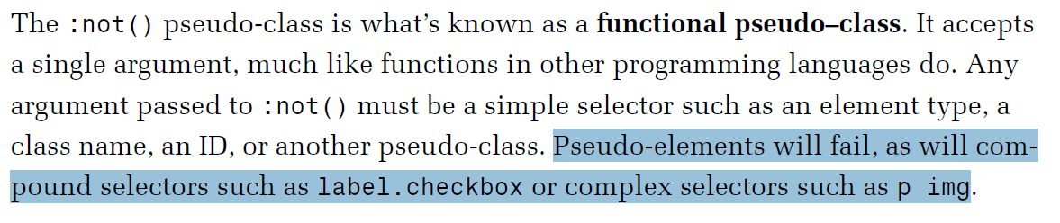

Citation: Brown, Tiffany B. “Negating Selectors with :Not().” *CSS Master Book*, SitePoint PTY. Ltd, 2015, p. 42. ¶3

Screenshots from VS Code showing the behavior contradicted the statement quoted. Looking at the blue highlighted line and then the applied classes under the Style window confirmed the behavior in Chrome.

